Name | Sanchay Ambokar
Roll no | 24204B0046
Batch | 03
Subject name | Python Programming & Data Structure
Teacher Name | Ms. Rasika Patil

Experiments | 14
Title | *a) Develop python program to implement Stack operations (PUSH, POP) using Array.  *b) Develop python program to implement Queue operations (enqueue, dequeue) using Array.

Programming Questions with Answer
1 | Program for Stack Operations Push, Pop, Display
SCRIPT | stack = []  while True:  print("\n1. Push")  print("2. Pop")  print("3. Display")  print("4. Exit")  choice = int(input("Enter choice: "))  if choice == 1:  item = input("Enter element to push: ")  stack.append(item)  print("Element pushed")  elif choice == 2:  if len(stack) == 0:  print("Stack is empty")  else:  print("Popped element:", stack.pop())  elif choice == 3:  print("Stack:", stack)  elif choice == 4:  break  else:  print("Invalid choice")
OP | 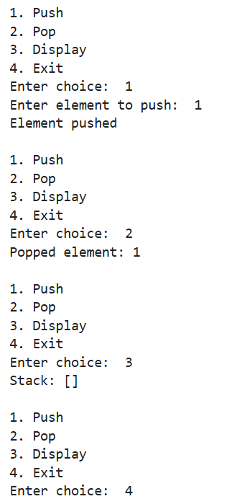
2 | Program for Queue Operations Insert, update, delete, display
SCRIPT | queue = []  while True:  print("\n1. Insert")  print("2. Update")  print("3. Delete")  print("4. Display")  print("5. Exit")  choice = int(input("Enter choice: "))  if choice == 1:  item = input("Enter element to insert: ")  queue.append(item)  print("Element inserted")  elif choice == 2:  pos = int(input("Enter position to update: "))  if 0 <= pos < len(queue):  queue[pos] = input("Enter new value: ")  print("Element updated")  else:  print("Invalid position")  elif choice == 3:  if len(queue) == 0:  print("Queue is empty")  else:  print("Deleted element:", queue.pop(0))  elif choice == 4:  print("Queue:", queue)  elif choice == 5:  break  else:  print("Invalid choice")
OP | 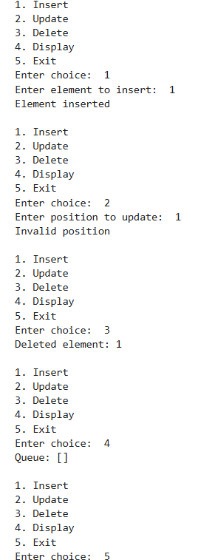
3 | Program to implement both Stack & Queue in same code
SCRIPT | stack = []  queue = []  while True:  print("\n1. Stack Push")  print("2. Stack Pop")  print("3. Stack Display")  print("4. Queue Insert")  print("5. Queue Delete")  print("6. Queue Display")  print("7. Exit")  choice = int(input("Enter choice: "))  if choice == 1:  item = input("Enter element to push into stack: ")  stack.append(item)  print("Pushed into stack")  elif choice == 2:  if len(stack) == 0:  print("Stack is empty")  else:  print("Popped from stack:", stack.pop())  elif choice == 3:  print("Stack:", stack)  elif choice == 4:  item = input("Enter element to insert into queue: ")  queue.append(item)  print("Inserted into queue")  elif choice == 5:  if len(queue) == 0:  print("Queue is empty")  else:  print("Deleted from queue:", queue.pop(0))  elif choice == 6:  print("Queue:", queue)  elif choice == 7:  break  else:  print("Invalid choice")
OP | 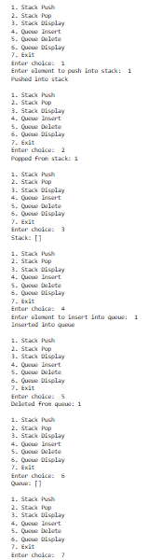
Debugging Questions with Corrected Answers
1 | Debug the following code  Wrong code:  stack = []  stack.pop(2)
OP | Error: 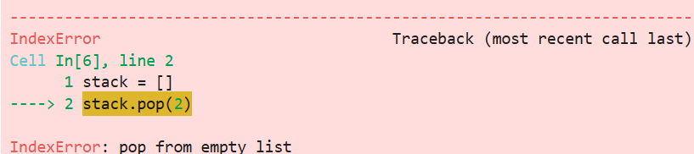  Correct code:  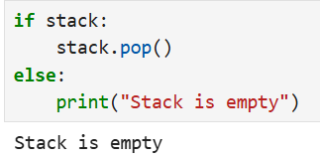
2 | Debug the following code  Wrong code:  queue = [1,2,3]  queue.pop()  print(queue)
OP | Error: No error  Correct code:  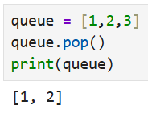
Conclusion

Performance Indicators |  | Teachers Dated and Signature
Process Related  (15 M) | Product Related  (10 M) | Total (25 M)

